**How many kinds of tables are present in hive and explain the difference between them with a demo**

There are two types of tables in Hive:

1. Managed table:

If a managed table is dropped, the data as well as the metadata are deleted.

2. External table.

If an external table is dropped, only metadata is deleted

Creating managed table:

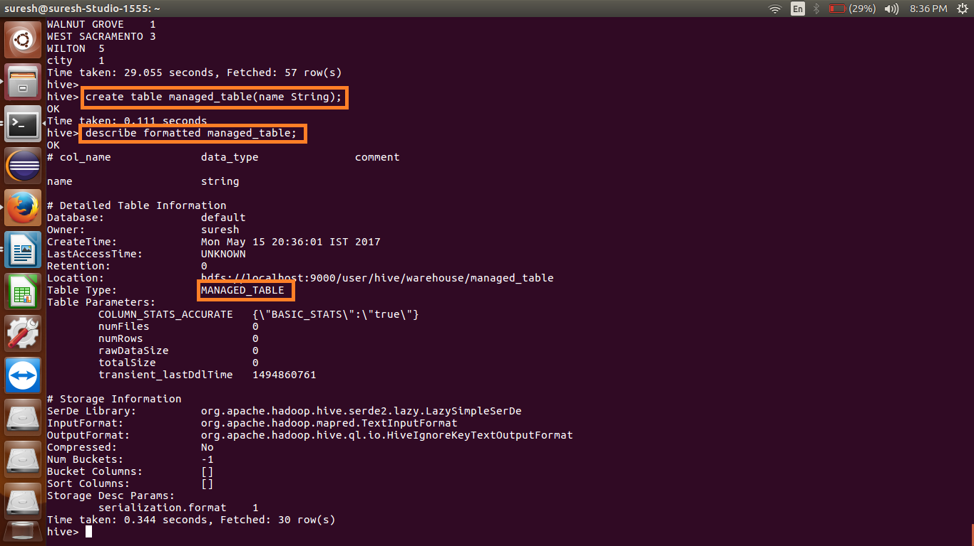

Creating external table: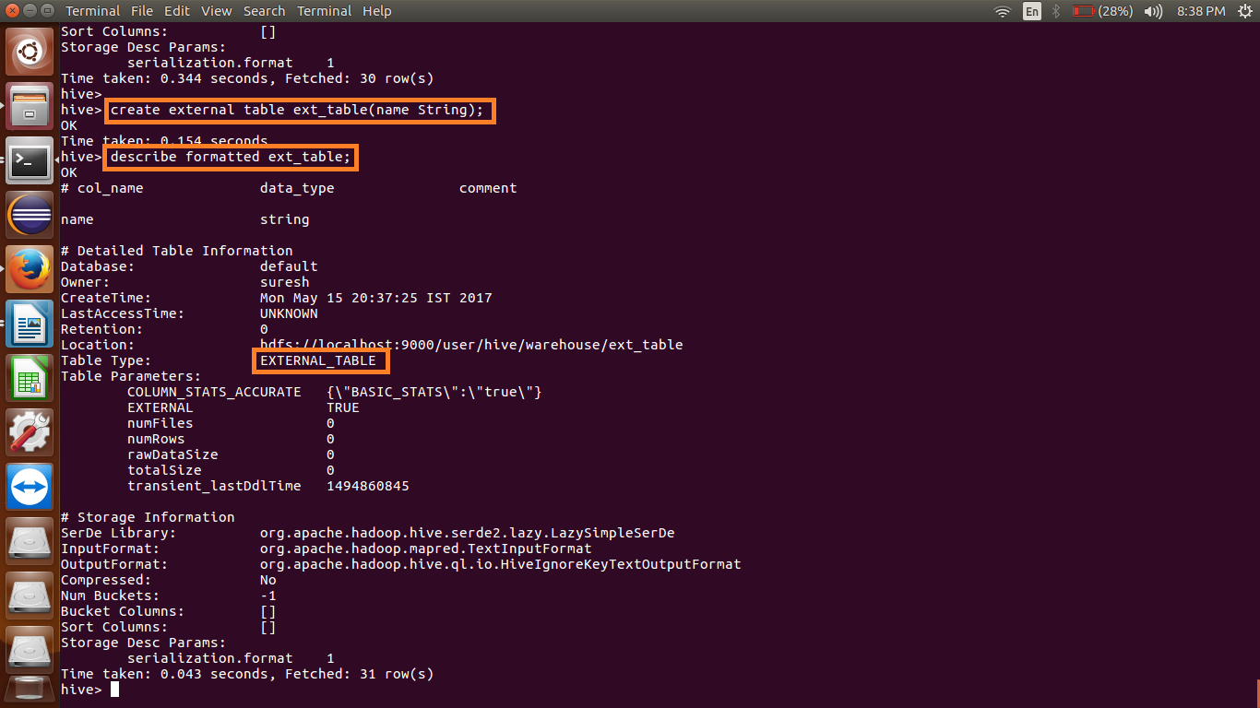

Dropping both the tables:



Listing the content inside the Hadoop directory:

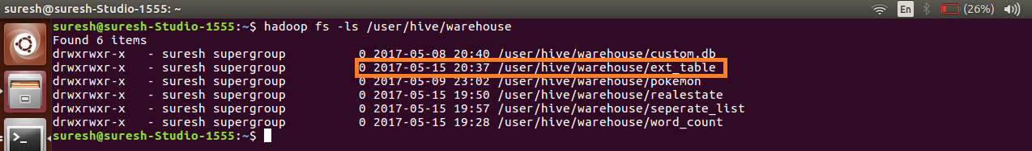

From the above screenshot we can see that metadata of external table is still present and the managed table is deleted.